# Benchmark study for similar Botanical Gardens PPP projects

The main objective of the benchmark study is to identify performance gaps and opportunities for improving the efficiency and effectiveness of the development of the NHBG botanic gardens by prospecting similar projects, and to understand the business models used for their economic developments.

In this section, we will present an international benchmark study of relevant PPP projects for botanic gardens and other similar cultural and touristic projects, namely:

* The public gardens of Ahmedabad in India;
* The Malta Landscaping Project; and
* The São Paulo Botanical Garden and Zoo in Brazil.

This benchmark study is based on documentary research as well as the consultant's experience in advising clients on different modes of PPP procurement for similar projects around the world.

## The public gardens of Ahmedabad in India

### Project Presentation

Ahmedabad is the largest city in the state of Gujarat and the seventh largest city in India. Ahmedabad Municipal Corporation (AMC) is responsible for the civic infrastructure and administration of the city of Ahmedabad. The area falling outside the periphery of AMC is maintained by Ahmedabad Urban Development Authority (AUDA).

Ahmedabad has a total of 214 Public Gardens. Maintaining these gardens cost the government a huge sum of money, a lot of effort to deal with different contracts and addressing people’s complaints. by The Ahmedabad Urban Development Authority (AUDA) came up with an innovative idea which could help the government cut down its cost on Garden maintenance- The Public Private Partnership (PPP) model. AUDA offered Anand Milk Federation Union Limited (AMUL) to maintain their gardens and in return AUDA would allow AMUL to put up a retail shop in the AUDA garden. The revenue from the shop would contribute to pay for garden maintenance. AMUL (Anand Milk Federation Union Limited) is an Indian dairy cooperative which spurred India’s White Revolution and made the country the world’s largest producer of milk and milk products. AMUL has expertise in making Milk and Milk products. But, to maintain so many gardens would require an organization which has proficiency in this sector. AMUL then approached Gujarat Environmental Service Society (GESS) a trust which was established by a group organization like AMUL, NDDB, GCMMF, Charotar Arogya Mandal, Elecon Engg. Co. Ltd, IRMA and member unions of GCMMF.

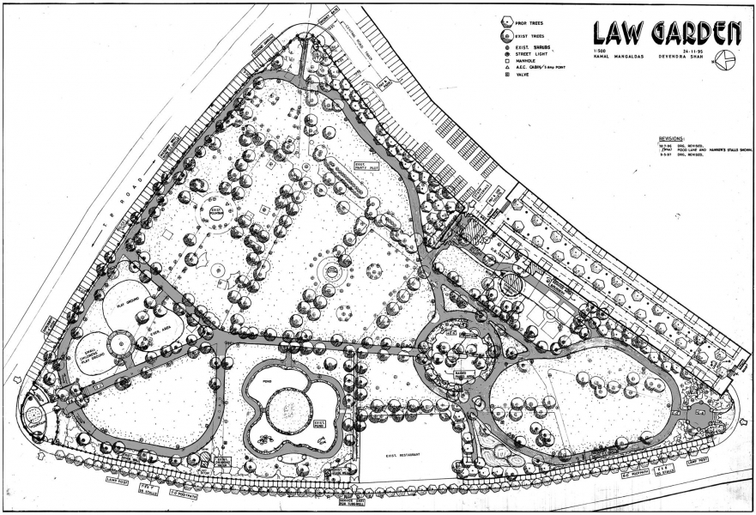

*Figure 1: Law Garden in Ahmedabad*

### Project Structuration

The project has been structured through an “O&M” contract. The private operator operates and maintains an asset for the public partner, usually at an agreed level with special obligations. Work is often subcontracted to specialised maintenance companies. It is here the case with the companies named previously. AMUL entered into a contract for garden maintenance with GESS where GESS is paid as per the actual cost incurred for the maintenance of the gardens and a fixed percentage of the expenditure as its profit. Having a single agency for the maintenance has helped AMUL decrease their effort and the continuity has helped in the improvement of the gardens.

## The Malta landscaping project/ the Malta Gardens

### Project Description

The Malta Gardens project, a landmark Public-Private Partnership (PPP) in Malta, commenced on November 1, 2002, marking a significant step in enhancing the environmental landscape of the Maltese Islands. The initiative, undertaken by the Malta Environmental and Landscaping Projects (MELP), focused on the landscaping and maintenance of public gardens, roundabouts, and central strips primarily on arterial and secondary roads. Responsibilities under this project included the meticulous monitoring of sites assigned to the Environmental and Landscapes Consortium Ltd. (ELC), verifying and approving new designs for soft and hard landscaping, and coordinating the use of public gardens for various activities. The project aimed to revitalize and maintain public spaces, contributing significantly to the aesthetic and environmental improvement of Malta's urban areas.

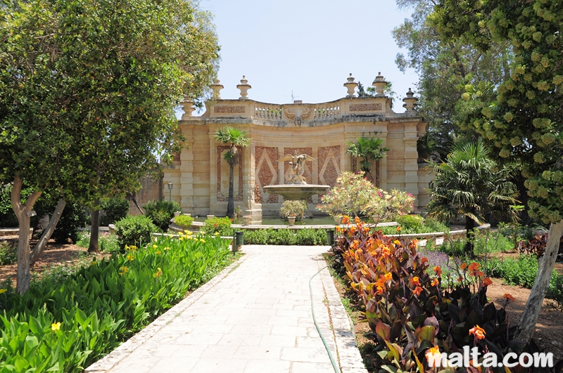

Figure 2 The Malta Gardens

### Project Structure

The PPP structure of the Malta Gardens project involved a partnership between the Maltese Government and ELC, with MELP overseeing and monitoring the contract's implementation. The original contractor, ELC, led by the Polidano Group, managed the project for nearly 20 years, with government expenditure exceeding €100 million during this period. The contract saw a change in 2022 when a €33.5 million contract was awarded to GEB Landscaping, led by V&C Contractors, Ozo Group, Derek Garden Centre, and Sicilville SRL. The contract, expected to run until 2027, includes a basic annual government funding of €6.7 million, with additional direct orders incurring extra costs. Throughout its tenure, the project faced challenges such as non-adherence to contractual provisions by the contractor, ineffective monitoring by the government, and issues regarding the negotiation, implementation, and enforcement of the contract, highlighting complexities in managing such large-scale PPP endeavors.[1]

ELC was delegated the responsibility to manage Government’s landscaping operations, utilize specified Government sites for commercial purposes (namely Wied Inċita Nursery) and undertake other gardening, landscaping and embellishment functions. Over the span of 15 years, the government’s expenditure relating directly to the 2002 Agreement and its two subsequent Contract Extensions amounted to over €100 Million. Only €43,223 were generated in 2016 through activities organized by ELC within the public gardens managed through this PPP Agreement. The Malta Embellishment and Landscaping Project (MELP) Monitoring Unit is responsible for the implementation and monitoring of this PPP Agreement.

The main thrust of the landscaping works related to the upkeep and maintenance of a number of sites around Malta and Gozo operations in an O&M (Operate and maintain) model. In 2016, the contracted allocation of this deliverable amounted to €8,650,000. The PPP Agreement, through its latest Addendum also refers to the undertaking of upgrading of existing landscaped areas and new projects where the Contract allocates €400,000 annually from 2014 onwards. Additionally, the Agreement also outlines various other deliverables. These include the undertaking of four medium-sized projects at the Contractor’s expense as a sign of co-operation and collaboration towards the PPP, the delivery of a training programme aimed at students following horticultural studies as well as the promotion and revenue generation through the utilization of public gardens maintained by the Contractor.

### Main challenges

Upon the evaluation of the PPP there was enough proof that the government did not reap the full benefits in terms of sites serviced since the footprint capacity of landscaping maintenance as provided for by the Contract remained not fully utilized. Such a situation implies contract management and monitoring shortcomings, which ultimately led to Government incurring additional expenses as ELC were awarded other contracts where the possibility existed for such works to be undertaken through the PPP Agreement.

Disputes over maintenance levels, which in part led to litigation between the Parties, highlights that mechanisms intended to ascertain that service delivery complies with contractual obligations including MELP’s direction were not fully operative. At the outset this highlights procedural weaknesses since the Contractor has, at times, changed maintenance levels of sites without prior formal authorization by MELP. Procedural failures became more exacerbated as the Parties did not find the means to resolve the significant variances, which inevitably resulted.

Service delivery concerns also relate to the non-completion of four medium-sized projects, which were to be undertaken at the Contractor’s expense as a sign of cooperation and collaboration towards the continued success of the PPP. The Contractor is contractually obliged to deliver these projects by end 2017.

## São Paulo Botanical Garden and Zoo, Brazil

### Project Description

The São Paulo Zoo and Botanical Garden project encompasses the São Paulo Zoological Park, Zoo Safari, and the Botanical Garden, located in the Fontes do Ipiranga State Park, a significant remnant of the Atlantic Forest in São Paulo. The objective is to enhance these areas through conservation, operation, and modernization, focusing on ecotourism, cultural sectors, leisure, and environmental education. The project aims to integrate public use with environmental education programs, leisure, culture, and more accessibility, integrating research activities at the Botanical Garden. At the Zoo, the focus is on providing more natural immersion and improved animal welfare.

Figure 3 São Paulo Botanical Garden and Zoo

*Source: https://naturezaurbana.net/en/projects/sao-paulo-zoo-and-botanical-garden/*

### Project Structure

This project is structured as a public-private partnership (PPP) for the concession of the Zoo and Botanical Garden, with the São Paulo government as the public partner. The concession period is set for 30 years starting from the contract award date which was on February 23rd 2021, and the winning private consortium is Consórcio Reserva Paulista. The total contract value is R$417.5 million (85.8 million USD), with a minimum investment of R$263 million (54.05 million USD) and R$180 million (37 million USD) in the first five years. The private partner is responsible for the conservation, maintenance, operation, and modernization of the parks, and they gain revenue through entrance fees and services offered within the park areas.[2]

## Summary of the benchmark study and lessons learned

Local Urban Bodies/ Cities have been adopting the PPP model in various infrastructure projects to achieve one or more than one the following objectives:

* Augmenting Funds
* Superior Project Delivery
* Improve Efficiencies & Competitive Environment.

In most of these infrastructure projects, the PPP models used are the **DBFOM, O&M and ROT models**. The revenue stream in most cases comes from user payments (leasing fees, commercial activities, etc.) with support from the government in the form of grants when needed.

There is no doubt that these projects have faced difficulties, delays, performance gaps and in extreme cases project cancellation (ex: The Malta Landscaping Project). To avoid such problems going forward with the NHBG botanical gardens Project, a number of recommendations should be taken into consideration.

First, **minimizing future deviations** from financial, economic, and social projections with respect to project outcomes at the initial preparation stages is a key success factor. There must also be a safe and stable return on investment (ROI) model in place – one that is fair to both private and public partners.

Under the PPP model where botanic gardens are financed with user fees, the private-sector partner assumes most of the financial risk associated with the garden. However, the accuracy of usage projections can be difficult to predict, and if there is a shortfall in the expected number of visitors, the private-sector partner may face financial stress. Although public entities may not experience significant financial losses if calculations are incorrect, they may still suffer if their private-sector partner must find workaround strategies to address a shortfall in visitors. For example, the private-sector partner may need to cut back on maintenance or reduce the quality of the visitor experience, which could harm the garden's reputation and reduce future demand for the garden.

1. https://www.gov.mt/en/Government/DOI/Press%20Releases/Pages/2017/October/02/PR172244en.aspx
2. https://g1.globo.com/sp/sao-paulo/noticia/2021/02/23/consorcio-reserva-paulista-vence-concessao-do-zoologico-e-jardim-botanico-de-sp.ghtml